Exploring Wildfire Spread Indicators to Determine if Land Vulnerability Predictions Could Be Improved

Your name here (student ID here)
Date here
Word Count:

Department of Geography and Environmental Studies, Toronto Metropolitan University

Abstract
The scale and danger of wildfires is a growing concern in Western Canada. Recently, British Columbia has experienced greater wildfire seasons due to extreme wildfire spread. The Northwest Fire Centre (one of six geographical wildfire prevention centres) covers 25 million hectares (equivalent to a quarter of the province) and experiences the lowest number of active wildfires in BC annually, yet, sees the greatest area burned from wildfire spread in the province. This study examines two Sentinel 2A images capturing the ‘before’ and ‘after’ of a major wildfire event that took place in the Northwest Fire Centre in 2018. The study positively reinforces the research question, that wildfire spread predictions may be drawn by collectively observing the Normalized Difference Vegetation Index, Normalized Difference Water Index, and slope calculations. The research further reveals that the region’s slope calculations play an important role for predicting wildfire spread patterns more accurately.

Key words: wildfires, spread, Northwest Fire Centre, British Columbia, Canada

Introduction
In recent years (2017-2019), British Columbia (BC) reported that the Northwest Fire Centre (NFC) had one of the lowest number of fires; yet, it had the greatest hectares burned due to wildfire spread. The NFC (one of six dedicated BC fire centres) is the largest wildfire response centre in the province, covering over 25 million hectares, equivalent to 25% of the provinces’ land area. The centre (Figure 1) stretches from the Pacific coast to just west of the Town of Endako and extends south from the Yukon border to Tweedsmuir Provincial Park (Government of British Columbia, 2020).
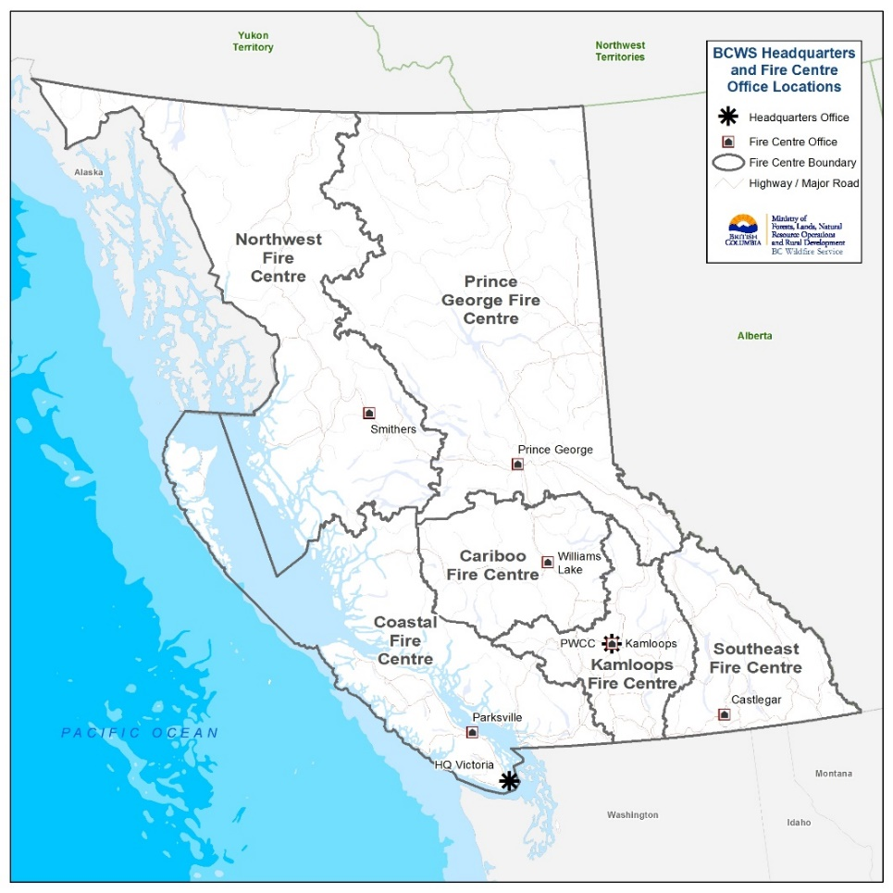
Figure 1. British Columbia’s regional fire centres (Source: Government of Canada, 2020)

Wildfire is a naturally occurring phenomenon during the summer months in BC. Wildfires can help ecoregions fight insect invasions, control the spread of disease, promote new vegetation growth, and in general, help maintain a healthy forest, promoting the diversity of both plant and animal life (Government of British Columbia, 2020). However, above-normal wildfire activity has occurred in BC over the last few decades. A history of effectively suppressing wildfire has led to a significant surplus/density of forest fuels, resulting in an increased risk of large wildfires, and as a side-effect, decreased forest biodiversity. With Western Canada showing above average temperatures and less precipitation (according to the Environment and Climate Change Canada (ECCC) climate research program), BC may see above normal wildfire season activity, resulting in potentially significant and devastating wildfires within the century (Government of Canada, 2020).
The study assesses a combination of three indicators: fuel availability, fuel moisture, and slope, to observe if they can be used to predict land vulnerability more accurately for wildfire spread within the NFC. Throughout the fire season, lightning strikes contribute to approximately 60% of wildfires in BC annually, the other 40% occur due to human negligence (Government of British Columbia, 2020). While reducing the number of human-caused wildfires is achievable through awareness initiatives and area blockages, lightning-caused wildfires are almost unavoidable.
As BC experiences more dangerous and unmanageable rapid wildfire spread, repairs and wildfire prevention efforts cost the BC government millions of dollars in situations where residents were forced to evacuate, or when fires burned excessive hectares of land. A total of $649 million (2017) and $615 million (2018) and $189 million (2019), were spent on wildfire prevention in the past few years (Government of British Columbia, 2020). In the 2017 and 2018 fire seasons, the BC government exhausted their resources and had to reach out to other provinces and countries for support in fighting the fires. Additionally, the damage caused by these wildfires resulted in 1.2 million hectares burned (2017), and over 1.3 million hectares (2018). These notable fires are damaging vital ecosystems, displacing residents, causing serious pollution to surrounding areas, and releasing millions of metric tons of CO₂ emissions into the air (Coogan et al., 2019).
In addition to the density/amount of fuels available and the moisture content/dryness of the fuels necessary for a wildfire to thrive, wildfire spread and its rate is often determined by the steepness of slope it is travelling on. The fire moves at an increased rate uphill on steeper slopes (wind promoting uphill spread) and falling debris contribute to downward slope spread (Government of Northwest Territories, 2020).
This research attempts to support the idea that an analysis of the Normalized Difference Vegetation Index (NDVI), Normalized Difference Water Index (NDWI), and slope of a past wildfire, could aid the BC government in predicting land that is vulnerable to wildfire spread. As climate change has been associated with rising temperatures, the damage and danger produced by large wildfires in BC is now greater and more serious than what has been known as normal within the region. By identifying land that is more vulnerable to wildfire spread, actions such as limiting human access to those areas could decrease the number of human-caused wildfires. Additionally, other precautions/actions can be taken during and ahead of fire season to prevent or better control spread. This paper will discuss the various impacts and associations that a large wildfire spread has in BC and around the world. Following the research context, the methodology being used for the research will be described and a discussion and analysis of the findings will determine if the selected approach will indeed better predict land vulnerability for wildfire spread.
Research Context
In Canada, most wildfires are managed through prescribed or controlled burnings rather than resorting to fire suppression methods. Wildfire is natural and beneficial to ecosystems and when there is no human or property threat, wildfire is managed rather than suppressed. When wildfires burn uncontrollably or too intensely, fire-management teams resort to suppressing wildfires to protect both residents and ecosystems (Government of British Columbia, 2020). In BC, wildfire predictions have often used the Moderate Resolution Imaging Spectroradiometer (MODIS) fire detection or the national fire database of Canada when investigating wildfire activity (Nurdiana and Risdiyanto, 2015).
With climate change on the rise, it has been predicted that in the next century, Western Canada’s forested regions could see a 50% or greater increase in wildfire spread days (length of time a wildfire stays active) (Wang, et al., 2017). The increase in spread days would mean that conducive wildfire weather conditions are present for longer periods resulting in larger wildfires annually. Wildfires spread either at a slow rate and low intensity, or at a fast rate and high intensity, but lengthening spread days increase the likelihood of burning considerable areas regardless of intensity (Podur and Watton, 2011). Now, with spread days increasing, it is important to study past wildfire spread activity to better prepare fire management teams in understanding where and how a wildfire will spread within ecoregions.
In 1958, BC had one of its worst wildfire seasons in history, burning 857,000 hectares of land (Flannigan, 2017). Fast forward to 2017, BC experienced a record-breaking wildfire season, burning 1.2 million hectares of land and forest area (Government of British Columbia, 2020). This was just after a devastating wildfire occurred in 2016, near Fort McMurray, Alberta, where 88,000 residents had to be evacuated and 589,995 hectares of land was destroyed (Mamuji and Rozdilsky, 2019). In 2018, once again, BC surpassed their own record with the fire season totalling 1.3 million hectares of land burned, accompanied with 66 evacuation orders affecting 2,211 properties.
In BC, there are several fuel management practices used to suppress or control the spread of wildfires, such as prescribed burning (Government of British Columbia, 2020). The process involves planning and burning a predetermined area with specific environmental conditions, to mitigate the severity of bushfires, maintain biodiversity, and help protect properties (Government of Western Australia, 2020). In a study conducted by Penman et al. (2014), fire management techniques were analyzed to observe their effectiveness in protecting properties affected by wildfire. Looking at California’s wildfires specifically, the authors found that fuel treatment, such as vegetation thinning, and fuel breaks, did not prove to be as effective when under extreme fire weather conditions, even when looking at high level fuel (Westerling, 2018). In addition to wildfire prevention techniques, wildfire management and suppression operations are mainly performed on the ground by firefighters as well as through aerial resources. With ground fire prevention operations, there is an evident risk to firefighter’s lives, however, new concerns have surfaced for aerial fire-control operations. When aerial resources are deployed to large wildfires, there are concerns that increased air traffic is a potential threat. As helicopters load and discharge water from multiple locations, with decreased air clarity due to thick smoke; this causes difficulties and increases collision risk (Rodriguez et al., 2018). As traditional fuel management practices are not proving to be as effective in containing spread, both residential and firefighter lives continue to be threatened. It is important to further study fire management techniques, as well as to accurately predict wildfire spread patterns, to apply resources appropriately to vulnerable spread areas, rather than taking general measures across the province prior to the fire season. With climate change impacting the scale of wildfire activity in Western Canada more than ever before (Thom, 2016), it is necessary to find improved ways of hindering wildfire spread to protect settlements, lives, and ecosystems.
As previously stated, large wildfires in BC burn a significant amount of land, impose a great expense to the government, result in a great loss of biodiversity, create a lot of smoke, and result in significant economic loss of resources (Nurdiana and Risdiyanto, 2015). In a study surrounding peat wildfires in Indonesia using Weighted Linear Combination (WLC) and regression techniques, it was concluded that the Normalized Difference Vegetation Index (NDVI) together with the Normalized Difference Water Index (NDWI) of pre-fire conditions, had over a 50% contribution to predicting land and forest vulnerability to wildfires. The study revealed that though surface and air temperatures were able to partially explain forest vulnerability, they were not as significantly effective in explaining wildfires in the region as vegetation and water indices (Nurdiana and Risdiyanto, 2015).
Similarly, Ferster et al. (2016), concluded that the traditional methods of observing wildfire vegetation loss through variables such as fuel type, canopy coverage and dry conditions, were universally applicable to wildfire activity predictions. Their study concluded that vegetation survival in wildfires occurred through intricate relationships between biotic and abiotic features. Particularly, they found that each ecoregion consisted of many additional contributing factors that impacted wildfire activity. Their recommendation for the improvement of forest management was to take a holistic approach to wildfire activity to improve prediction models and enhance wildfire control practices. Applying their recommendation, this study’s analysis of fuel availability and fuel moisture conditions in combination with slope, examines these wildfire conducing factors in the ecoregion. This analysis will further assess how slope could influence wildfire spread pattern and assist in making more accurate wildfire prediction in the Northwest Fire District of BC.
When predicting the wildfire season in BC, dry conditions and high temperatures have a huge influence on the expected number of high-severity fires. These large wildfires cause greater forest destruction and can significantly decrease forest recovery or lengthen recovery processes (Baker, 2015). Wildfire activity and behaviour can change rapidly, so the BC Wildfire Service has classified fire behaviour into six numeric ranks. The ranks are determined by a wildfire’s active appearance (ground fires, surface fires, crown fires and candling fires), and severity. The most notable wildfires in BC’s history had all ranked between 4 (Highly vigorous surface fire with torching or passive crown fire) and 5 (extremely vigorous surface fire or active crown fire) (Government of British Columbia, 2020). Due to their aggressive behaviour, wildfires ranked 4-6 have the greatest spread and cause the most damage, therefore, have been investigated by other researchers to better predict vigorous surface fire or crown fire spread. Models such as Rothermel’s Model (1991), the Van Wagner Model (1993), the Cruz et al. Model (2005), have been tested on their accuracy of predicting fire spread, with the Cruz et al. Model proving to be a more accurate model for crown fire spread (Baker, 2015). With many existing wildfire prediction models and spread models, this research paper aims to further improve spread analysis by analysing the three indicators; fuel availability, fuel moisture and slope, will be visually observed to test if they are able to influence fire spread significantly and in turn, further benefit the study of fire spread models and spread prediction practices.
Methodology
Pre-fire and post-fire satellite images for the study area found within the Northwest Fire Centre, BC, will be assessed to determine if the Normalized Difference Vegetation Index (NDVI), Normalized Difference Water Index (NDWI), and slope, can improve the accuracy of wildfire spread predictions. For this study, conditions prior to the devastating lightning-caused wildfire that burned over 100,000 hectares in the NFC, near Lutz Creek (south of Watson Lake, Yukon) on August 4th, 2018 (Government of BC, 2020) will be assessed. The results will be compared to the post-wildfire spread/vegetation loss, to determine if these indicators can accurately identify areas most vulnerable to wildfire spread and observe if those areas did burn due to wildfire spread.
The remotely sensed images used in this study are acquired from the United States Geological Service (USGS) Earth Explorer data portal (U.S. Geological Survey, 2020). The Sentinel 2A images were acquired on May 16th, 2018 and September 19th, 2018. The images are projected in NAD1983 UTM Zone 9N, and have a highest spatial resolution of 10 metres. The boundary file for the NFC being used is acquired from the Government of British Columbia’s Data Catalog (Government of British Columbia, 2020).
The geoprocessing of the data is preformed in ArcGIS Pro (2018) where the NFC border features are utilized for selection and extraction. For both images, the NDVI and NDWI calculations are completed by using the spatial analyst tool, ‘raster calculator.’
The following equations are used:
NDVI Calculation [float (Band 8- Band 4) / float (Band 8+ Band 4) (1)
NDWI Calculation [float (Band 11- Band 8) / float (Band 11+ Band 8) (2)
ArcGIS Pro automatically adjusts the pixel resolution to 20 by 20 metres for the raster output. In Sentinel 2 images, Band 11 has a spatial resolution of 20 metres while Band 8 has a spatial resolution of 10 metres. To match the pixel size, ArcGIS increases the cell value size of the remaining bands to 20 metres (see Table 1).
Table 1. Spatial bands adjusting pixel size.

Band 4 | 10m x 10m
Band 8 | 10m x 10m
Band 11 | 20m x 20m
Band 4 | 20m x 20m
Band 8 | 20m x 20m
Band 11 | 20m x 20m

The purpose of this process is to show the differences in healthy vegetation and moisture content pre and post wildfire. For NDVI, the results will show a range between -1 (low levels of vegetation) and +1 (high levels of vegetation/healthy vegetation). For NDWI the results will show a range between -1 (high moisture content in vegetation) and +1 (low moisture content in vegetation). To better observe the pre-fire and post-fire conditions, the NDVI and NDWI results of the post-fire are subtracted from pre-fire images by using the raster calculator to reveal the total loss of vegetation as well as observe the vegetation moisture conditions from May 2018 to September 2018.
To better predict the spread vulnerability of the area, slope is calculated by the ‘raster slope’ function. The slope results are calculated with a z factor of 1 metre. The z factor of 1 is used because the x and y cell size unit of measurement is represented in metres (ESRI, 2020). The slope results are reclassified into five classes for easy interpretation through the spatial analyst tool ‘reclassify.’
The NDVI and NDWI results of both images are also reclassified into five classes to allow the raster join of all three indicators. For the reclassification of the NDWI results, the class ranks are inverted to combine and correctly represent the raster classes. As a result, the combined map will show the steepest slope results, highest NDVI results, and lowest NDWI results. The reclassified raster classes are added by the following calculation using the Spatial Analyst Tool, ‘Raster Calculator:’
(Reclassified NDVI results + reclassified NDWI results + reclassified Slope results) (3)
To represent land vulnerability, the most common fire susceptibility method used is the natural breaks classification. This representation method creates classes of similar values and separates them at breakpoints to effectively categorize the data, showing the levels of vulnerability and allows for easy interpretation (Ghorbanzadeh et al., 2019).
This process will reveal the final wildfire spread vulnerability map, representing the least vulnerable areas to the most vulnerable areas for wildfire spread. Additionally, the moderately vulnerable to vulnerable areas will be extracted through the raster calculator for all three indicators and combined into two maps, one including and one excluding the slope results. The image with the slope indicator included will be compared to the map of just the NDVI and NDWI results combined. By observing vulnerability patterns, we can determine if there is greater accuracy for predicting wildfire spread when slope results are included. The results will be compared to the NDVI change results that show the location and outline of the burnt area.
Discussion and Results
The focus of this research is on the notable lightning-caused wildfire that occurred at Lutz Creek in the Nilkitkwa Complex found within the Northwest Fire Centre; 23 km south of Watson Lake and 14 km southwest of Lower Post. The wildfire was discovered on August 5th, 2018 and destroyed 100,227 hectares of forested area (Government of British Columbia, 2020), the second largest wildfire that occurred during BC’s fire season of 2018. The change in NDVI from May to September shows the immensely burnt area (Figure 2).
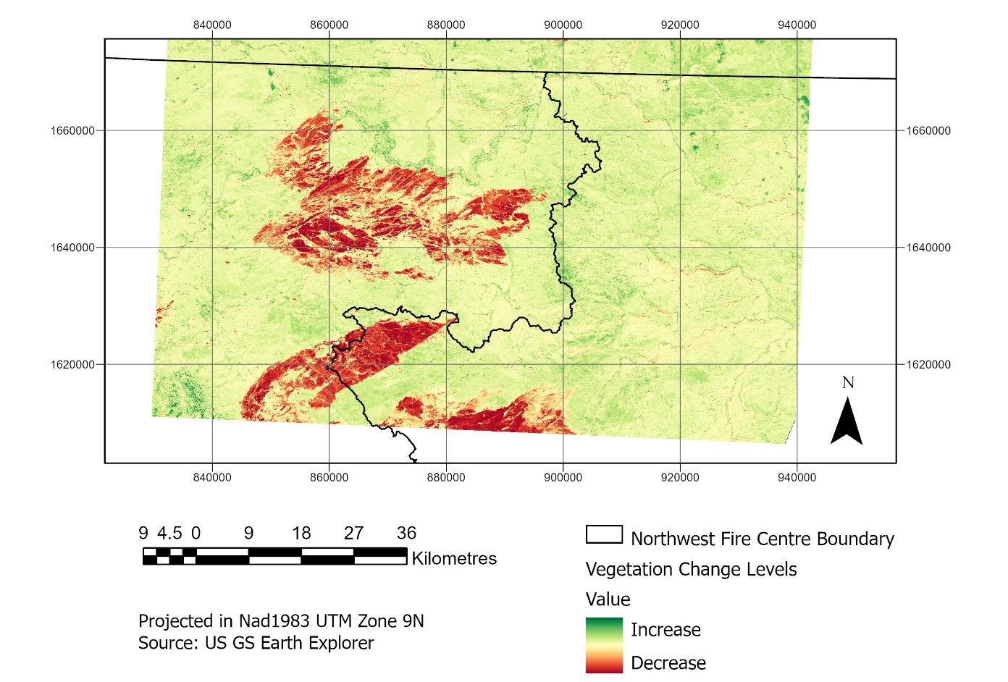
Figure 2. Burnt area caused by the 2018 wildfire of Lutz Creek as well as the fuel health difference between May and September.

For this study, focus is placed on the large burnt area in the centre of the image (Lutz Creek fire). The burnt area shown further south, was a separate wildfire incident that burned extensively into the neighbouring Prince George Fire Centre. Focusing on the burnt area in the NFC, there are a few visible dense areas with extreme burn scars caused by high intensity burning. These scars are all connected through pathways of low-medium intensity burning shown by a shade lighter.
This study will show that three indicators: Normalized Difference Vegetation Index (NDVI), Normalized Difference Water Index (NDWI), and slope, can better predict wildfire spread. For the interest of this research, the scar connecting pathways will be further looked at to determine if spread predictions by the three indicators could have predicted the spread pattern found between these major scars. By examining the Lutz Creek wildfire, the research attempts to highlight land vulnerable to wildfire spread accurately. The definition of vulnerability being used for this paper is defined by, “how easily damaged a particular value is to a fire of a given intensity (CIFFC, 2017).” This definition is being applied not to how vulnerable the land itself is to a wildfire but how vulnerable the land is to the spread of wildfire.
Looking at the NDVI results from the May and September images (Figures 3 and 4), the results show a value range between -1 and 1. Low NDVI (below 0) shows there is little vegetation to none with high NDVI (above 0) showing there is healthy and more plentiful vegetation according to USGS, 2020. In Figure 3, we can identify a few small areas with very high NDVI results (0.6-0.9 range) however most of the landscape shows an expected result of (0.1-0.6 range) healthy vegetation. In Figure 4, we can see by the NDVI results that the vegetation levels have not changed much, with exception to the loss of vegetation where the wildfire occurred.
Taking a look at the NDWI results from May to September images (Figures 5 and 6 ), the results show a value range between -1 and 1. Low NDWI results (below 0) show there is low- very low moisture content in the vegetation, showing there is water stress. High NDWI results (above 0) shows there is greater moisture content in the vegetation (USGS, 2020). In Figure 5, the results show moderate levels of moisture in the vegetation with some areas water stressed and a few extremely water stressed spots. In Figure 6 however, the results show even lower NDWI levels, meaning there is greater water stress in the area.

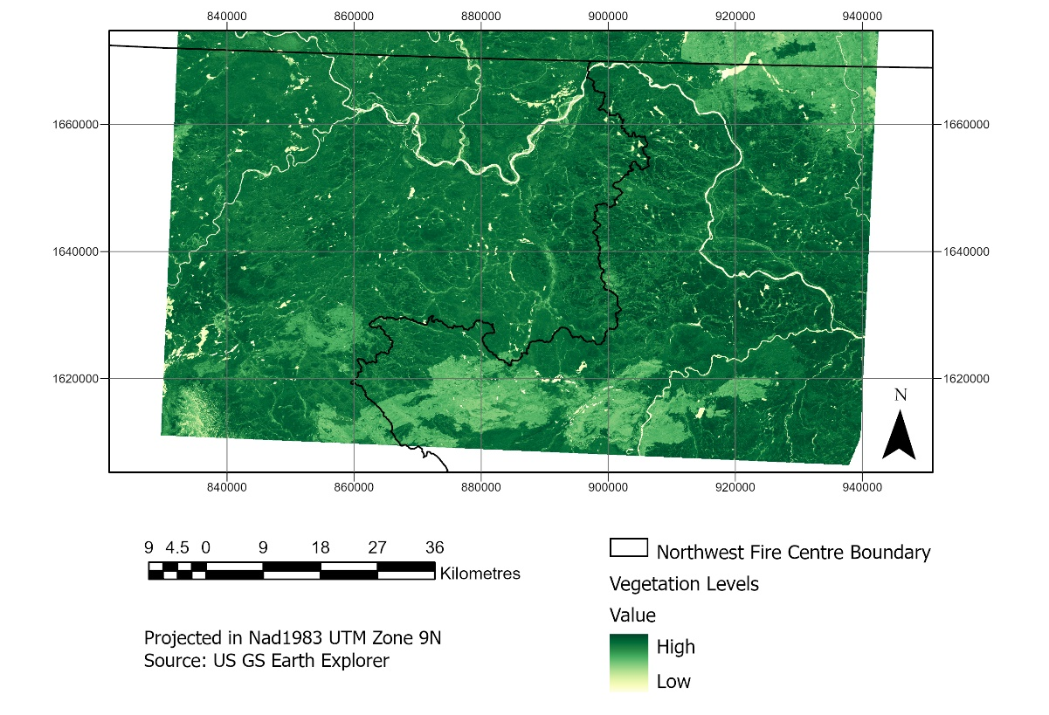
Figure 3. May NDVI Calculation Results (Fuel health pre-fire)

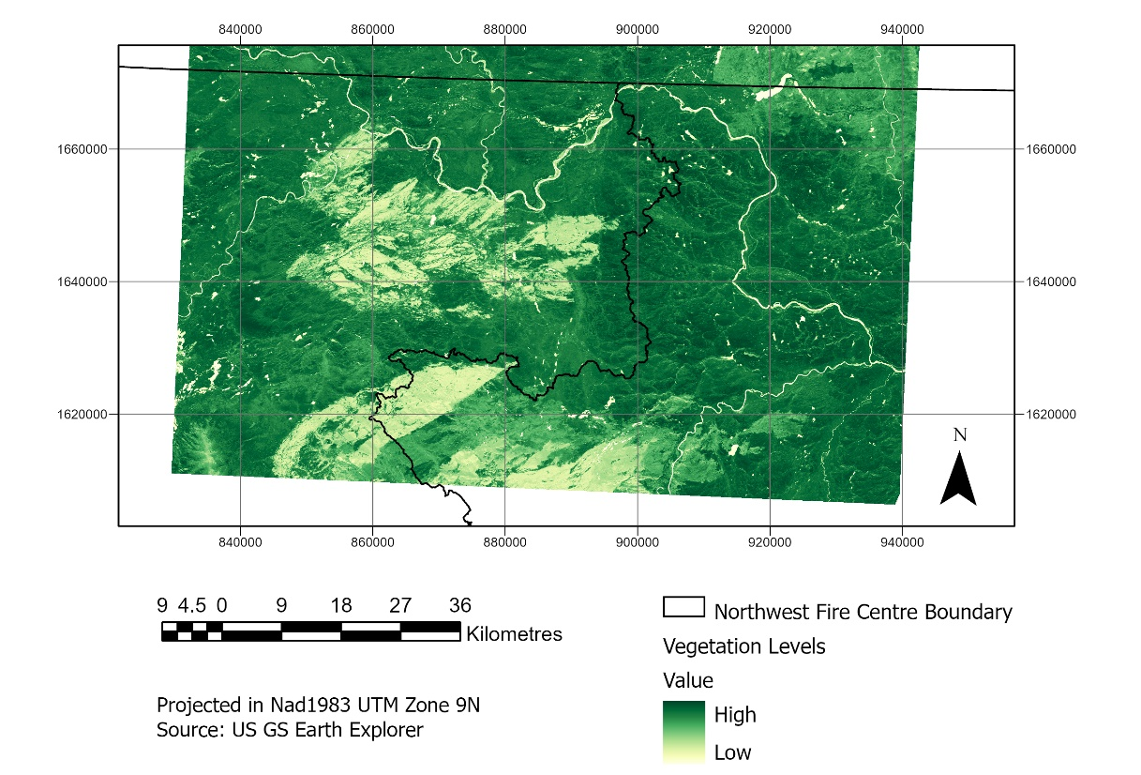
Figure 4. September NDVI Calculation Results (Fuel health post-fire).

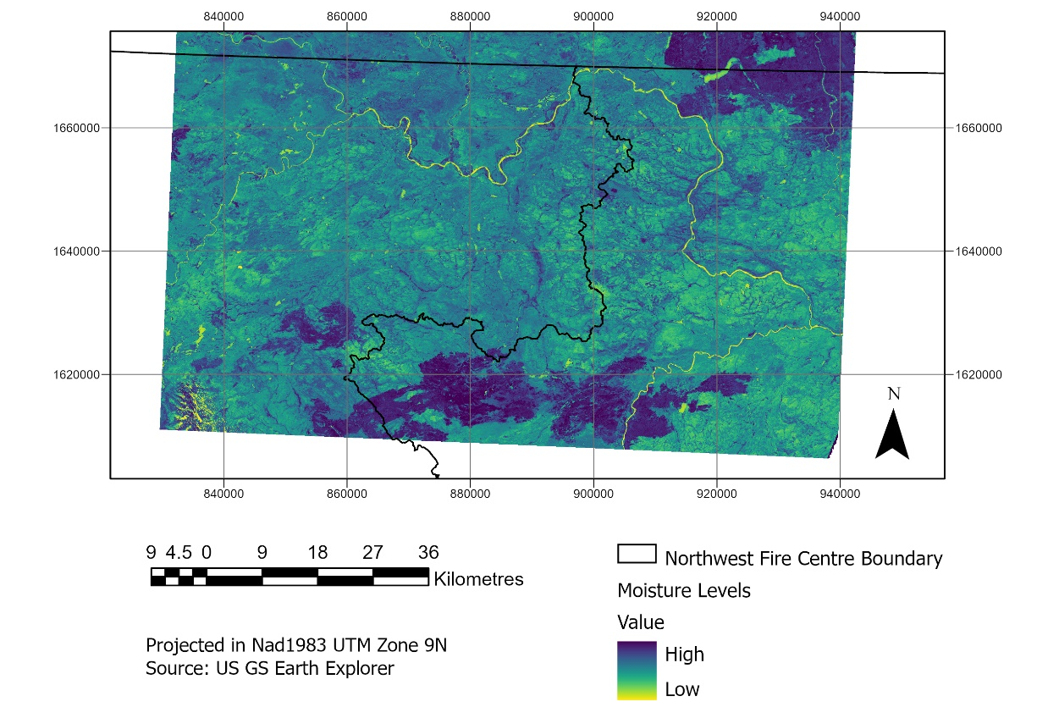
Figure 5. May NDWI Calculation Results (Fuel moisture content pre-fire).

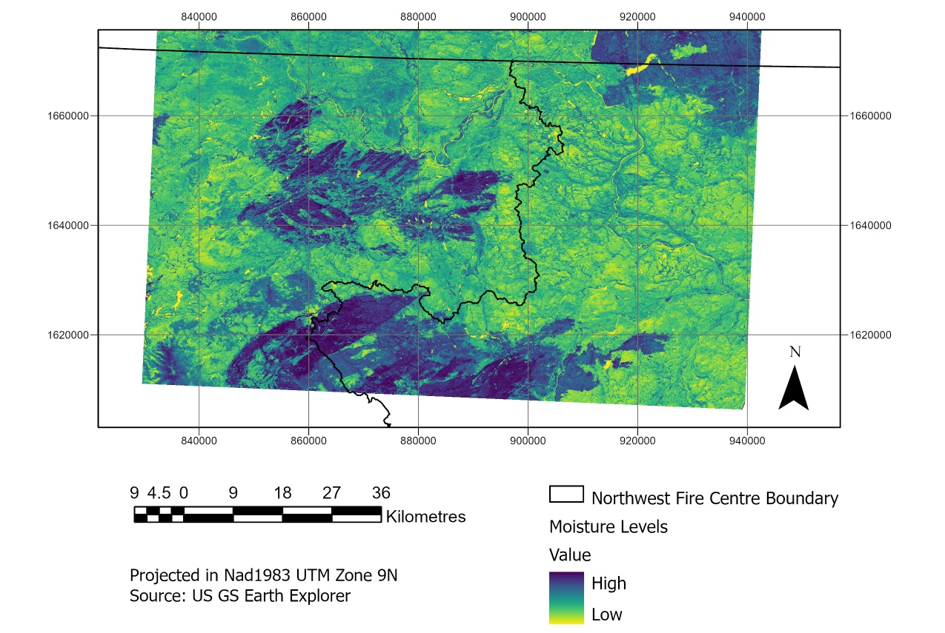
Figure 6. September NDWI Calculation Results (Fuel moisture content post-fire).

Table 2. Mean Differences from May to September

Image | NDVI mean | NDWI mean
May | 0.418 | -0.114
September | 0.460 | -0.230
Change Difference | 0.042 | -0.116

Taking a closer look at the changes from May to September (Figures 2 and 7) as well as the results in Table 2, it shows that in May the mean NDVI result is 0.418 and mean NDWI result is -0.114. This shows the vegetation is healthy but has a slight low water content. The September mean NDVI result is 0.460 and the mean NDWI result is -0.230, this shows the vegetation is slightly healthier than May, but more water stressed. The increase of 0.042 in mean NDVI from May to September can be attributed to the natural increase in vegetation growth due to the summer months and warm temperatures promoting healthier growth. Additionally, the increasing temperatures and low precipitation of the summer months experienced by BC have resulted in a lower water content and caused greater water stress on the vegetation, explaining the -0.116 mean NDWI change. Overall, the mean NDVI and mean NDWI results from May to September show that there was a healthy concentration of fuels increasing but also experiencing more water stress through the summer months, which ultimately fueled the wildfire that took place.

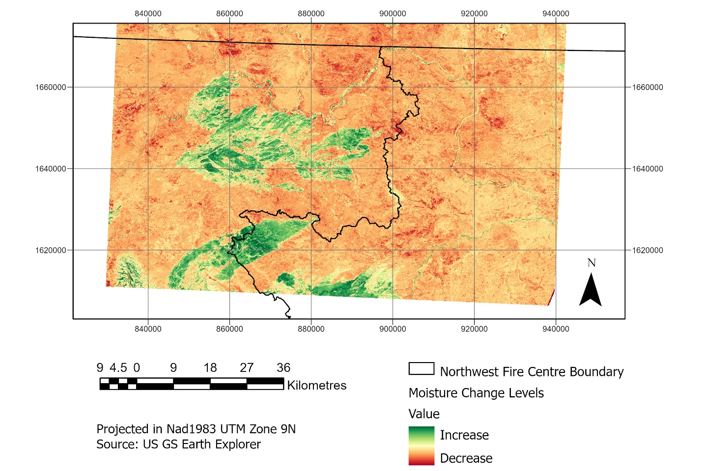
Figure 7. Changes in NDWI from May to September (Fuel moisture difference between May and September).
Looking at the reclassified raster results of NDVI and NDWI (Figure 8), the results show quite a few clusters of high vulnerability with most of the map showing as having moderately high vulnerability. Though the area shows high vulnerability clusters where fire may thrive and spread, the area highlighted provides only a general picture of the locations where wildfire may spread.
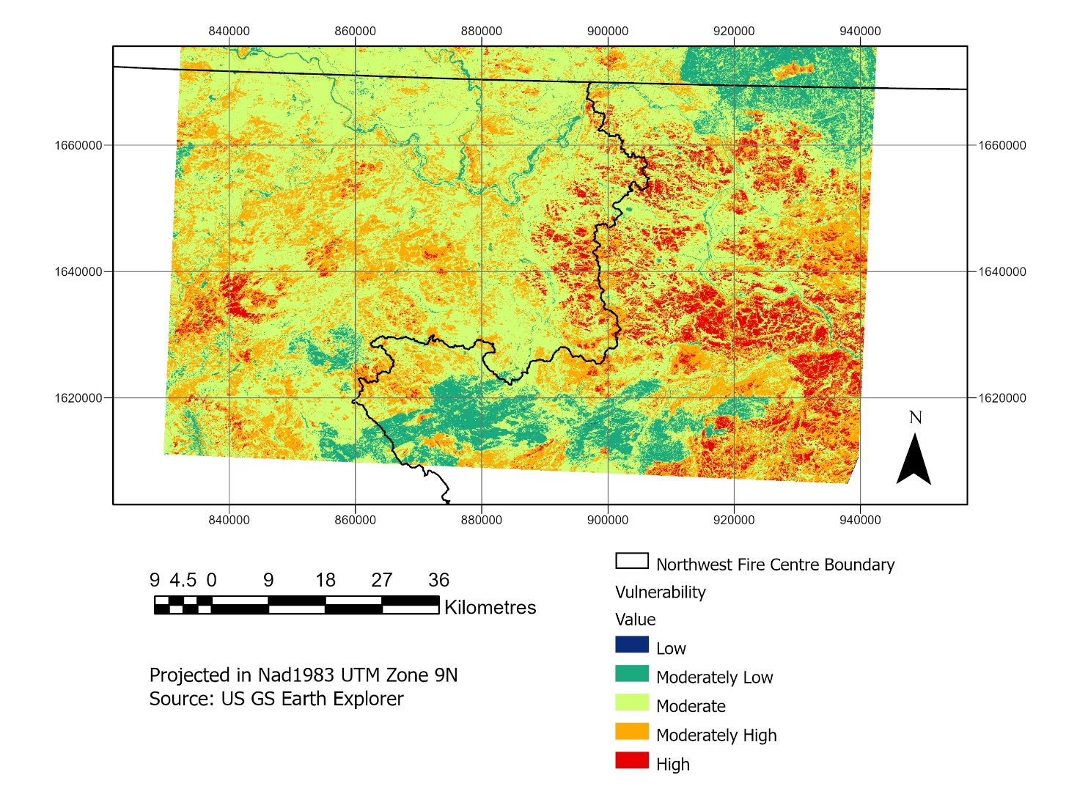

Figure 8. Land vulnerability based on high NDVI results and low NDWI results.

When looking at the reclassified raster results of NDVI, NDWI and slope combined (Figure 9), more of the land is identified as vulnerable with greater highlights being placed in the general area where the wildfire took place. We can see more of a reflected shape to where the fire burned and can see that there is an area near the NFC boundary that could link the affected area with the extremely dry neighbouring area.

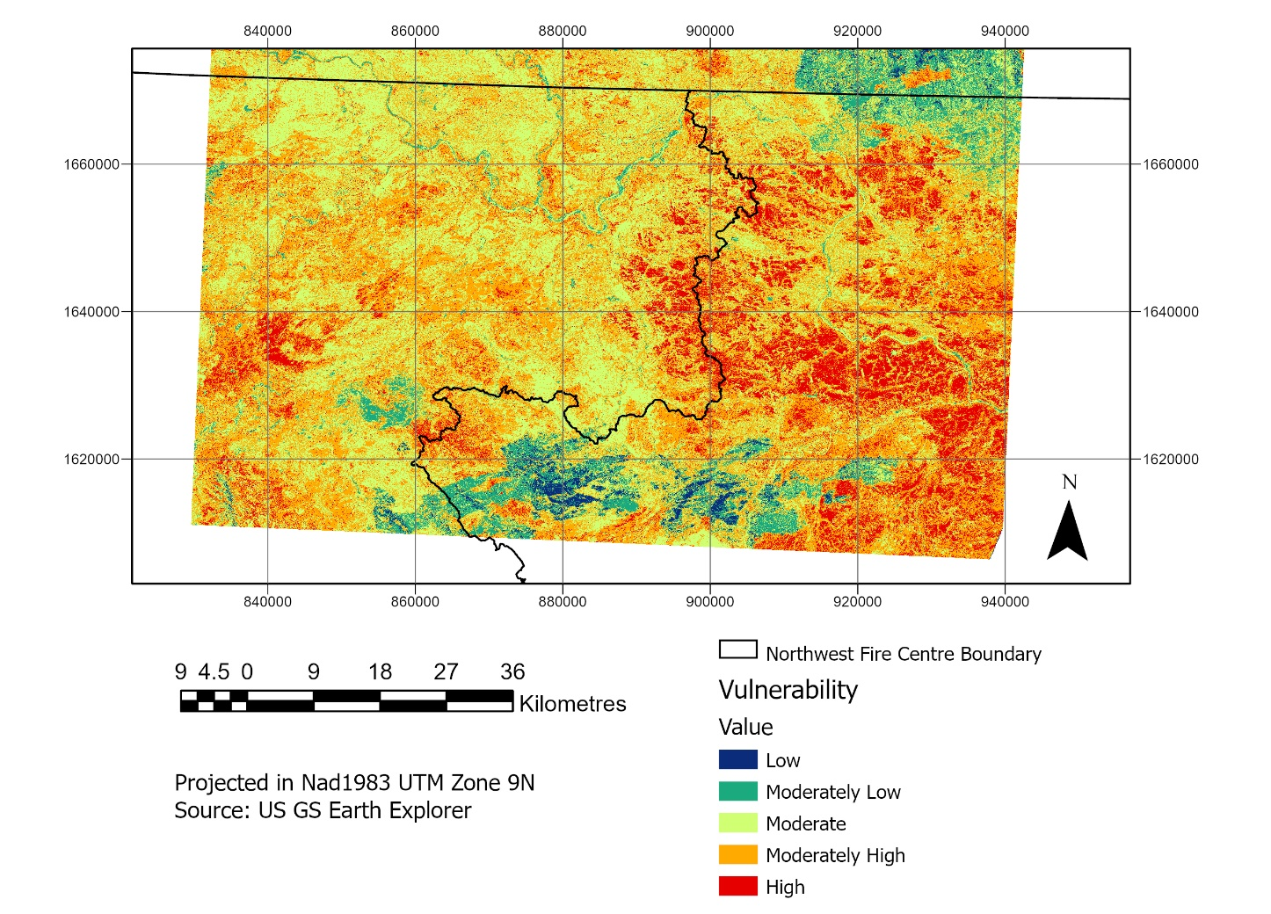
Figure 9. Land Vulnerability based on high NDVI, low NDWI and Slope Results.

To show how important it is to look at the slope in the ecoregion, the moderately vulnerable to vulnerable results of the NDVI and NDWI results are extracted. The output classes identify that raster data greater than 7 represents moderately vulnerable to vulnerable areas. For the combined results (NDVI, NDWI & Slope), the classes too identify that raster data greater than 7 represents moderately vulnerable to vulnerable areas. The results are extracted and compared on a large scale as well as on a small, selected area (Figures 10 and 11). Both scenarios are compared to the burnt area (calculated by the change in NDVI from May to September). Immediately, when looking at just NDVI and NDWI results, it is very difficult to determine how or where a fire might spread in the case of a wildfire (Figures 10a & 10b). Looking at the NDVI, NDWI, and slope maps (Figure 11a and 11b), greater similarities are seen to where the fire spread. Taking a closer look at the randomly selected areas (Figures 10b & 11b), the cluster of identified vulnerable areas, where slope is involved, shows very similar pattern to how the wildfire spread. These data do not match the post-fire burned area entirely, however, they show a relatively similar pattern and outline to how the fire spread. For fire prevention efforts, the three combined indicators could greatly assist in accurately predicting how a wildfire might spread. The three indicators can therefore identify how vulnerable land is to wildfire and provide a general picture of how/where a wildfire could spread through the region, focusing more on highly clustered areas/more vulnerable areas to spread.
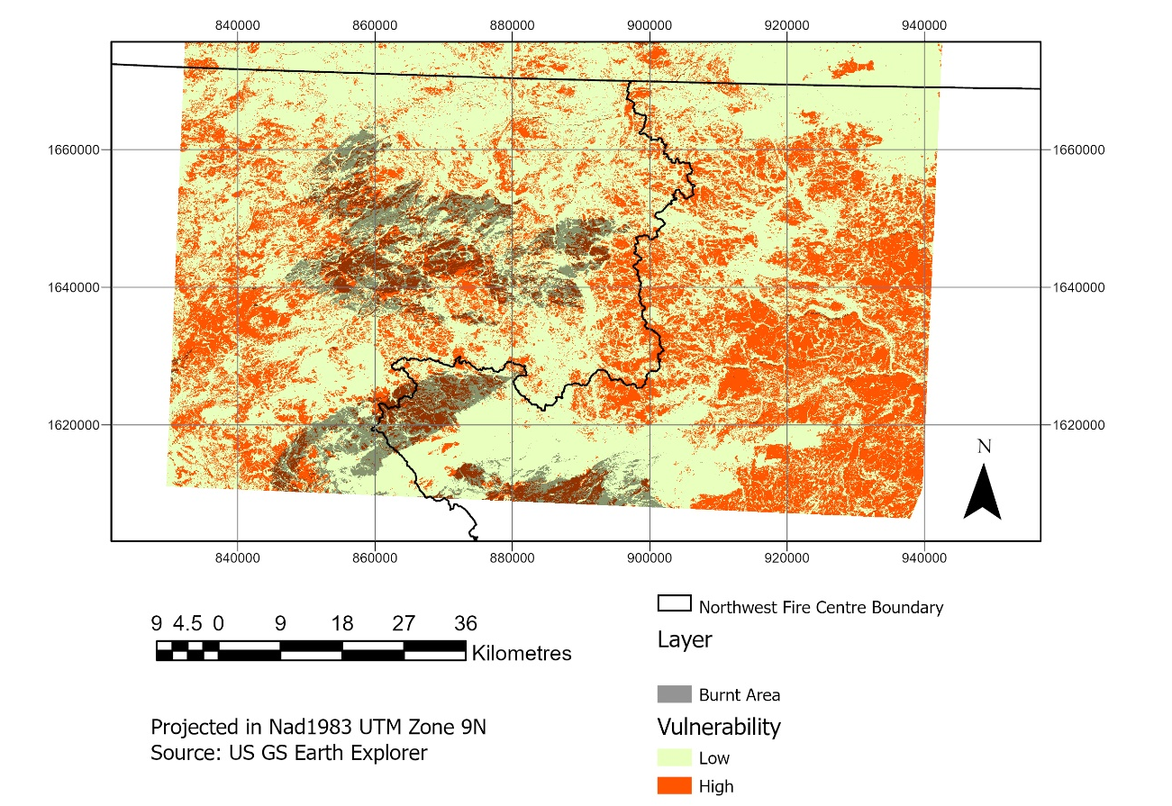
Figure 10.a. Most Vulnerable Areas Identified by NDVI and NDWI Compared to Burned Area -the highest NDVI and lowest NDWI results (moderately vulnerable- vulnerable)
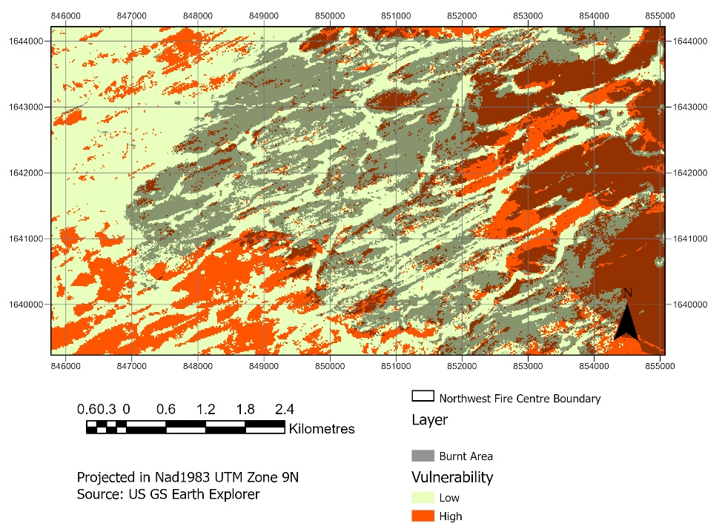

Figure 10.b. Most Vulnerable Areas Identified by NDVI and NDWI Compared to Burned Area - zoomed in area of the highest NDVI and lowest NDWI results (moderately vulnerable- vulnerable)

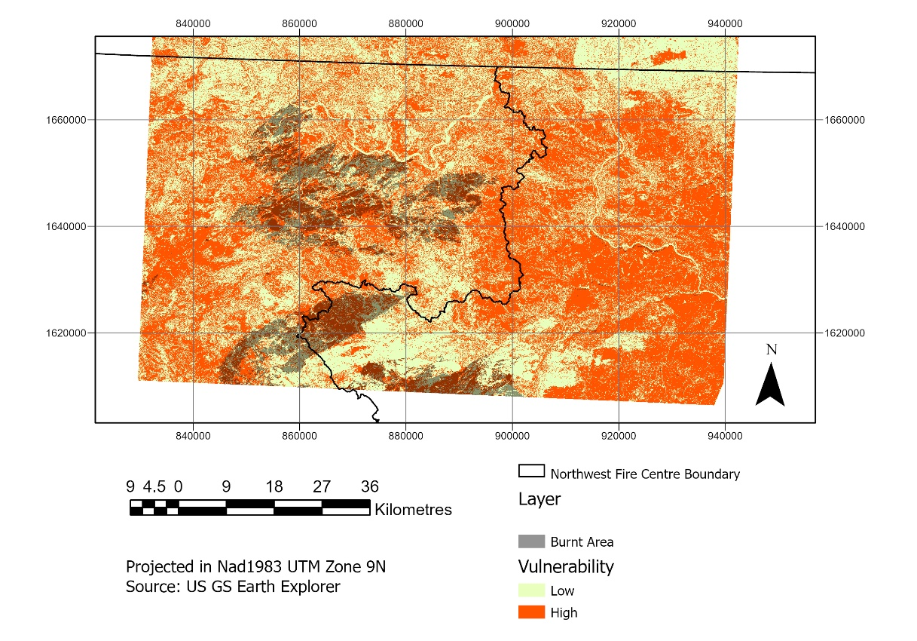
Most Vulnerable Areas dentified by All Three Indicators Compared to Burned Area Figure 11.a. The highest NDVI and lowest NDWI results (moderately vulnerable- vulnerable) with the Steepest Slope.a
s Identified by All Three Indicators to Burned Area 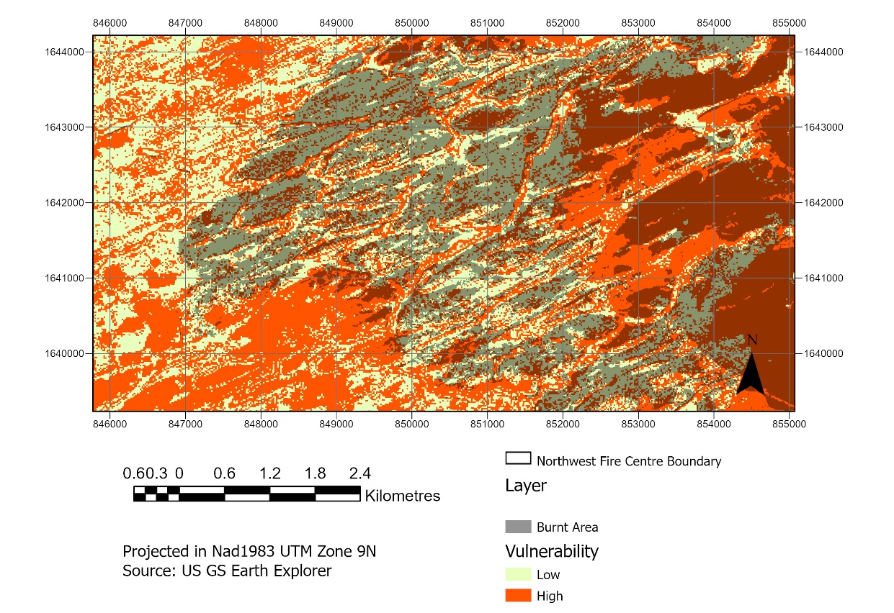
Figure 11.b Zoomed in area of the highest NDVI and lowest NDWI results (moderately vulnerable- vulnerable) with the Steepest Slope.

Conclusion
The study assessed a combination of three indicators: fuel availability, fuel moisture, and slope, using a major wildfire example from within the Northwest Fire Centre, BC, to observe if they can be used to more accurately predict land vulnerability for wildfire spread. To obtain the required data, NDVI was calculated to represent fuel availability as well as to see the wildfire spread/burned area. To obtain fuel moisture data, NDWI was calculated to observe how healthy the vegetation is in the ecoregion and to see how water stressed its fuels were. Finally, slope was calculated to determine where in the ecoregion wildfire spread is more likely. The findings confirm that the assessment of these three indicators do in fact help predict land vulnerability for wildfire spread. The results show that the slope was a very important indicator for determining how a wildfire could spread through the ecoregion. Without the slope indicator, the NDVI and NDWI results did not identify with the same level of accuracy the vulnerable land that would burn, or influence wildfire spread. Slope alone does not predict vulnerable areas for wildfire spread but when the three indicators are combined, they present a fairly precise representation of where/how a wildfire may spread.
This knowledge could potentially be applied to help fire management teams better predict, prepare, and monitor a wildfires activity. This information would be most beneficial in a scenario where a wildfire was to reach a rank 4 (or greater) to slow down the spread at vulnerable points or if a wildfire would occur near settlements to assess the danger. Additionally, since wildfires are best left alone to run their course, fire management teams can predict how much impact a certain wildfire may have and decide whether to interfere earlier depending on how much spread potential may exist.
Finally, for particularly dry seasons, this prediction method could identify large clusters of extremely vulnerable land to wildfire spread and regions could take proper precautions and limit human access to the areas identified. This would help prevent accidental human negligence fires that account for 40% of all BC wildfires (Government of BC, 2020). Since the data will show dispersed amounts of vulnerable areas to wildfire spread, the BC fire centres cannot protect all identified vulnerable areas but this could decrease the chances of very dangerous and large fires from occurring unnaturally in extremely vulnerable areas identified.
The study could be further developed by adding other indicators such as slope aspect or surface temperatures. It would be also be beneficial to have these data available and incorporate daily wind conditions as wind could have a great impact on the spread of wildfire, especially in vulnerable areas surrounded by steep slopes. Though the study can be developed further, the study does confirm that looking at NDVI, NDWI and slope indicators, can better predict wildfire spread.

References
Baker, W.L. 2015. Are high-severity fires burning at much higher rates recently than historically in dry-forest landscapes of the western USA? PLoS One, 10(9).
CIFFC Glossary Task Team and Training Working Group. 2017. Canadian Wildland Fire Management Glossary. Canadian Interagency Forest Fire Centre Inc. Retrieved from https://www.ciffc.ca/sites/default/files/2019-03/CIFFC_Canadian_Wildland_Fire_Mgmt_Glossary_2017_10_24.pdf
Coogan, S.C.P., Robinne, F-N, Jain, P., and Flannigan, M.D. 2019. Scientists’ warning on wildfire - a Canadian perspective. Canadian Journal of Forest Research. 49(9): 1015-1023.
Cruz, M.G. and Alexander, M.E. 2006. Evaluating a model for predicting active crown fire rate of spread using wildfire observations, Canadian Journal of Forest Research, 36(11), 3015-3028.
ESRI. 2020. Applying a z-factor. ArcGISPro Tool reference.
Ferster, C-J., Eskelson, B.N.I., Andison, D.W., and LeMay, V.M. 2016. Vegetation mortality within natural wildfire events in the western Canadian boreal forest: What burns and why? Forests, 7(9), 187.
Flannigan, M. 2017. The 2017 Canadian wildfire season. Canadian Wildland Fire Smoke Newsletter, p 19. Retrieved from: https://docs.wixstatic.com/ugd/90df79_bfcc500b532a4e38abaa78e1ecfdd26b.pdf.
Ghorbanzadeh, O., Blaschke, T., Gholamnia, K., and Aryal, J. 2019. Forest Fire Susceptibility and Risk Mapping Using Social/Infrastructural Vulnerability and Environmental Variables. MDPI Journal
Government of British Columbia. 2020. Wildfire History- Wildfire Season Summary and Statistics. Government of British Columbia. Retrieved from: https://www2.gov.bc.ca/gov/content/safety/wildfire-status/about-bcws/wildfire-history/wildfire-season-summary
Government of Canada. 2020. Climate Trends and Variations Bulletin Winter. Government of Canada. Retrieved from: https://www.canada.ca/en/environment-climate-change/services/climate-change/science-research-data/climate-trends-variability/trends-variations/winter-2020-bulletin.html
Government of Northwest Territories. 2020. Environment and Natural Resources- Wildfire Operations- Fire Behaviour, 2020. Government of Northwest Territories. Retrieved from: https://www.enr.gov.nt.ca/en/services/wildfire-operations/fire-behaviour
Government of Western Australia. 2020. Prescribed Burning. Department of Biodiversity, Conservation and Attractions, Government of Western Australia. Retrieved from: https://www.dpaw.wa.gov.au/management/fire/prescribed-burning#:~:text=Prescribed%20burning%20is%20the%20process,burns%20are%20the%20same%20thing.
Mamuji, A.A. and Rozdilsky, J.L. 2019. Wildfire as an increasingly common natural disaster facing Canada: understanding the 2016 Fort McMurray wildfire. Nat Hazards 98, 163–180
Nurdiana, A. and Risdiyanto, I. 2015. Indicator determination of forest and land fire vulnerability using Landsat-5 TM data (Case Study: Jambi Province). Elservier-Procedia Environmental Sciences.
Penman, T. D., Collins, L., Syphard, A. D., Keeley, J.E., and Bradstock, R.A. 2014. Influence of fuels, weather, and the built environment on the exposure of property to wildfire. PLoS One, 9(10)
Podur,J. and Wotton, M. 2011. International Journal of Wildland Fire. 20:497-507.
Rodríguez-Veiga, J., Gómez-Costa, I., Ginzo-Villamayor, M., Casas-Méndez, B., and Sáiz-Díaz, J.L. 2018. Assignment problems in wildfire suppression: Models for optimization of aerial resource logistics. Forest Science, 64(5), 504-514.
Thom, D. and Seidl, R. 2016. Natural disturbance impacts on ecosystem services and biodiversity in temperate and boreal forests. Biol Rev, 91: 760-781.
U.S. Geological Survey, 2020. Earth Explorer data portal.
Wang, X., Parisien, M.A., Taylor, S.W., Candau, J.N., Stralberg, D., Marshall, G.A., Little, J. M., and Flannigan, M.D. 2017. Projected changes in daily fire spread across Canada over the next century. Environmental Research Letters, 12(2), 025005
Westerling, A.L. and Bryant, B.P. 2018. Climate change and wildfire in California. Climatic Change 87, 231–249.

